Lab 11: Basic Data Operations

Part 1. INSERT

Step 1. Create a schema and the Students table
DROP SCHEMA IF EXISTS lab11 CASCADE;
CREATE SCHEMA lab11;
SET search_path TO lab11;
CREATE TABLE students (
student_id SERIAL PRIMARY KEY,
first_name VARCHAR(50),
last_name VARCHAR(50),
birth_date DATE
);

Step 2. Insert one student
INSERT INTO students (first_name, last_name, birth_date)
VALUES ('Zhamilya', 'Kambaraalieva', '2005-03-14');
SELECT * FROM students;
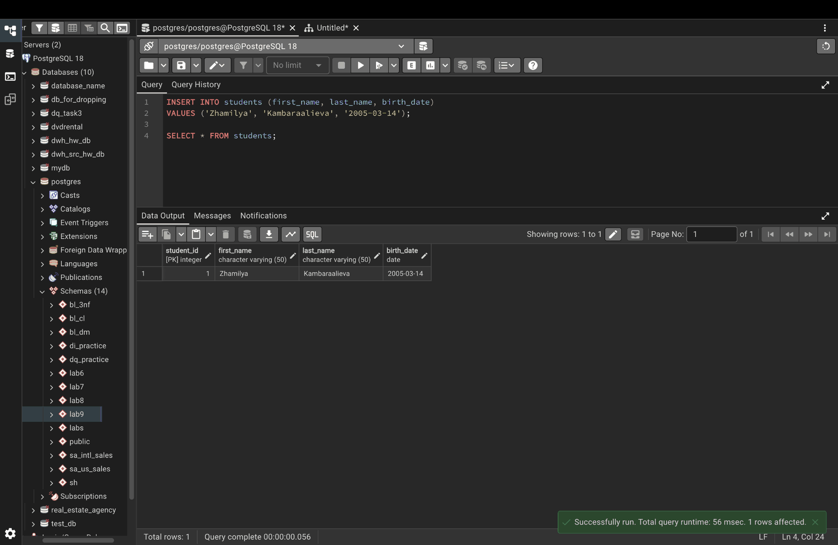

Step 3. Insert several students at once
INSERT INTO students (first_name, last_name, birth_date) VALUES
('Aibek', 'Sharshenov', '2002-05-12'),
('Ainura', 'Toktomamatova', '2001-09-23'),
('Bakyt', 'Mamatov', '2003-01-15'),
('Gulzat', 'Sultanova', '2002-07-30'),
('Emir', 'Uulu', '2000-12-01');
SELECT * FROM students ORDER BY student_id;
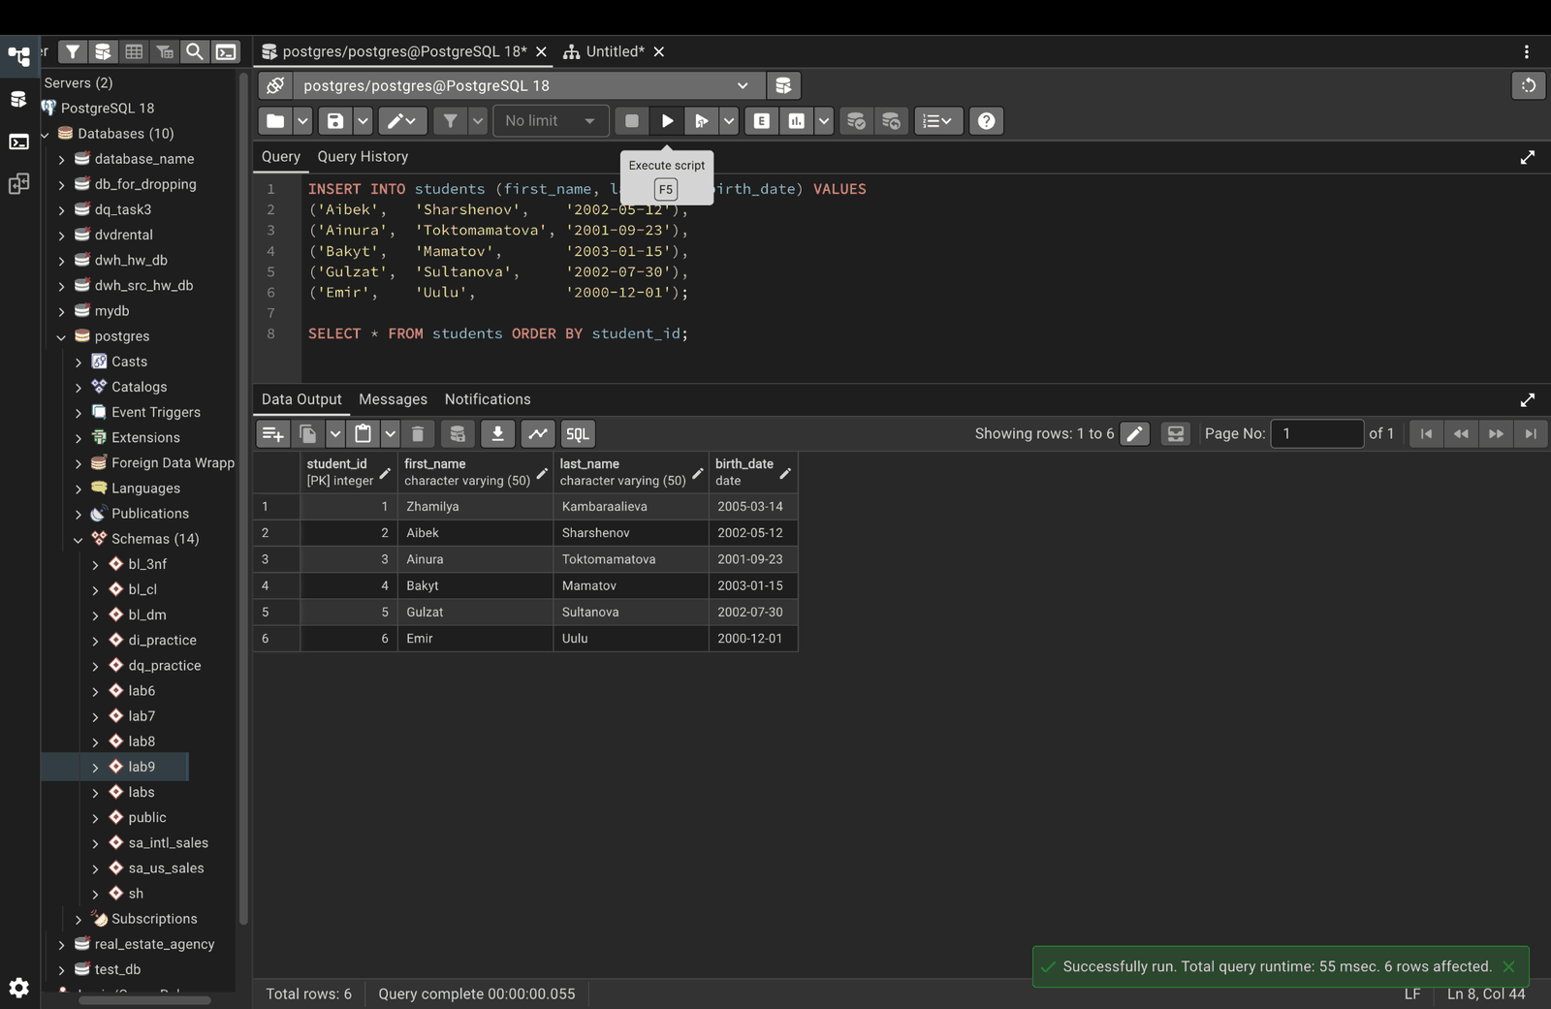

Step 4. INSERT with RETURNING
PostgreSQL can show the new row (with its generated id) right after inserting.
INSERT INTO students (first_name, last_name, birth_date)
VALUES ('Aigerim', 'Asanova', '2004-08-19')
RETURNING *;
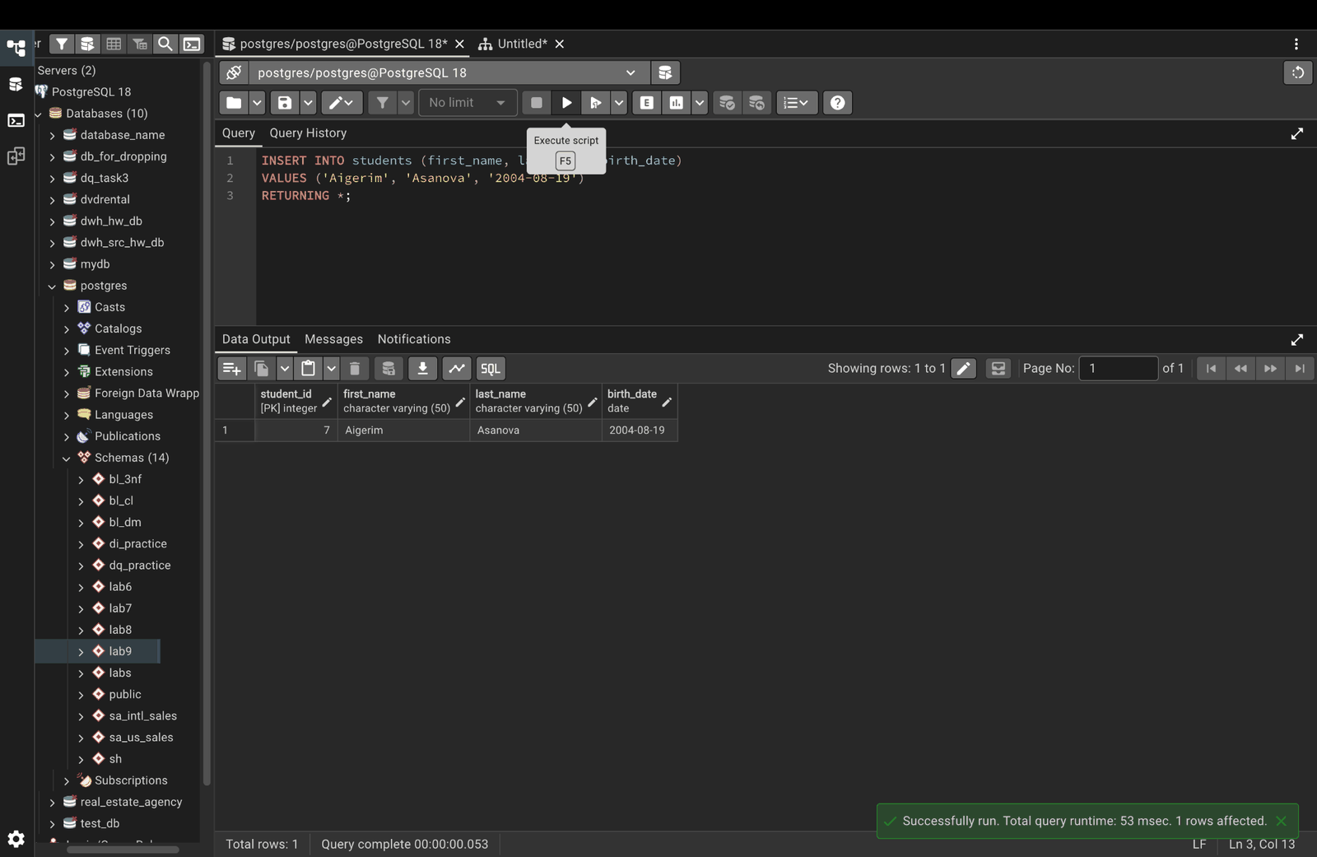

Part 2. UPDATE

Step 5. Update one row
UPDATE students
SET birth_date = '2002-05-15'
WHERE first_name = 'Aibek' AND last_name = 'Sharshenov';
SELECT * FROM students WHERE first_name = 'Aibek';
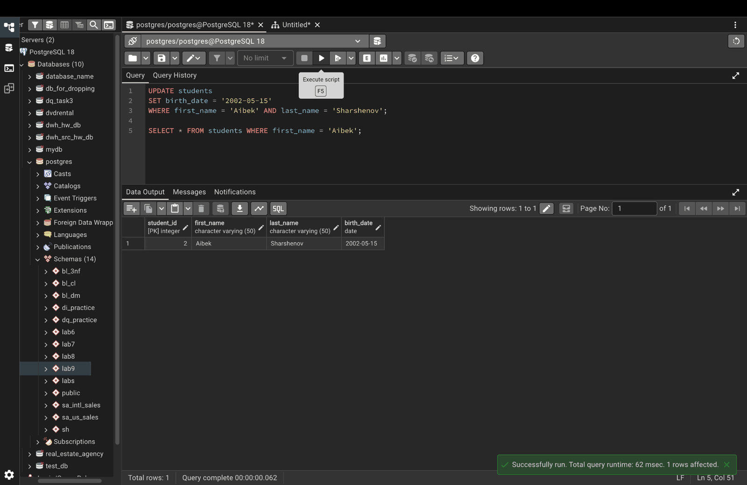

Step 6. Update several columns at once
UPDATE students
SET first_name = 'Ainura-Maria', birth_date = '2001-09-24'
WHERE student_id = 3
RETURNING *;
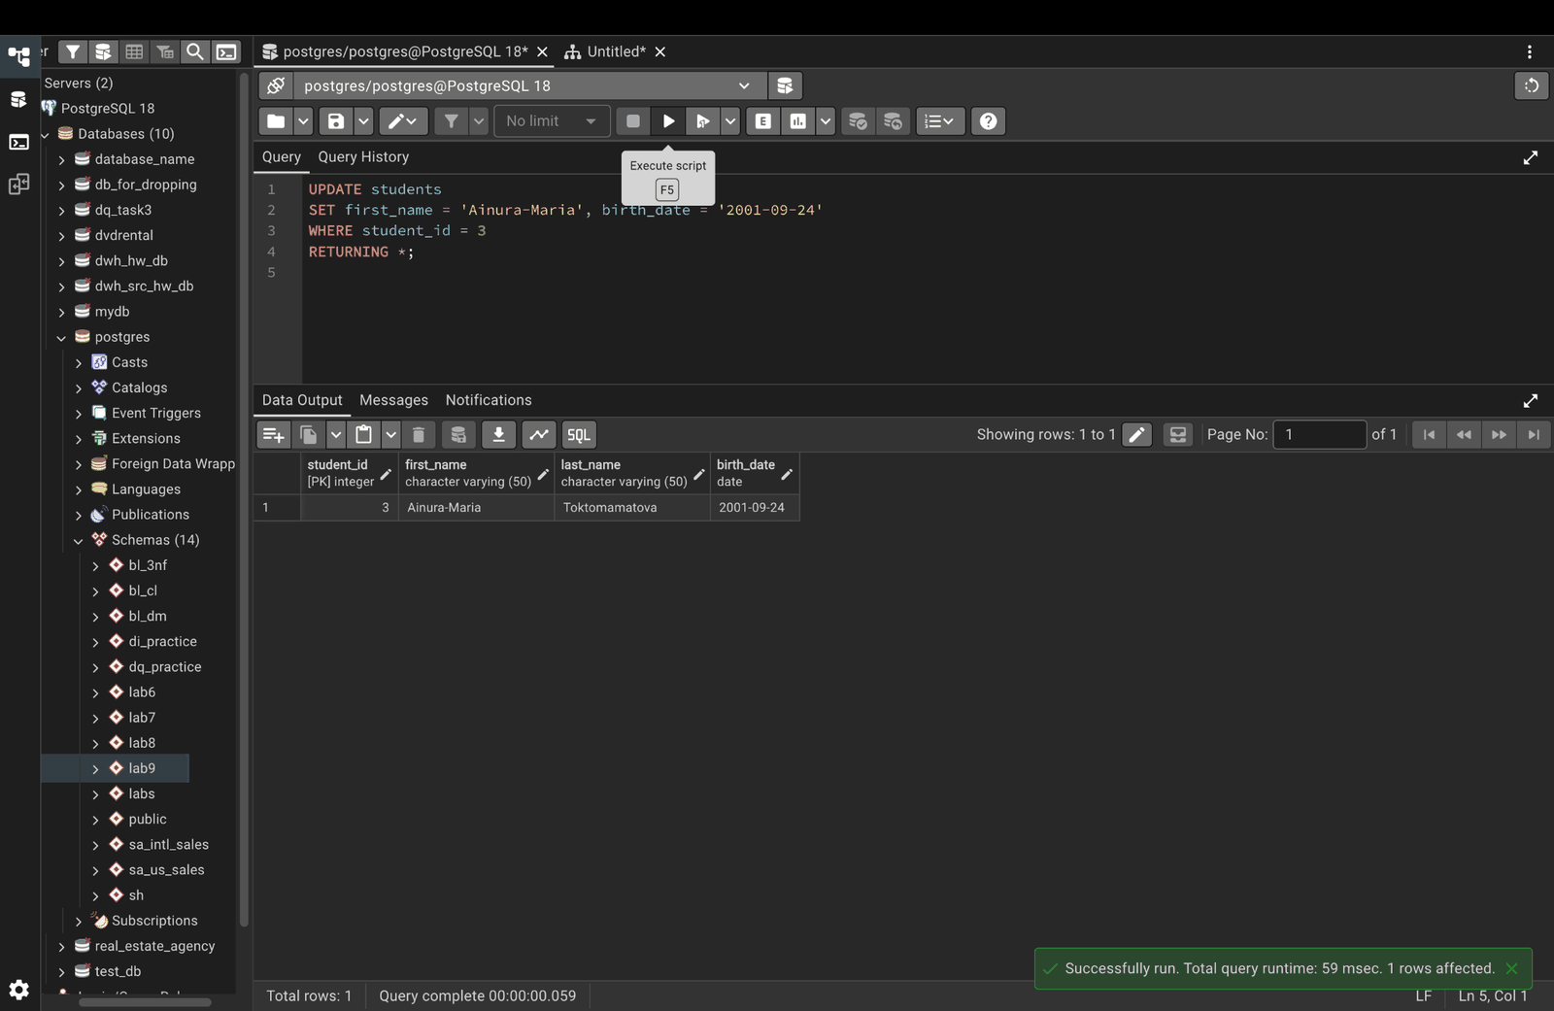

Part 3. DELETE

Step 7. Delete one row
DELETE FROM students
WHERE first_name = 'Gulzat' AND last_name = 'Sultanova';
SELECT * FROM students ORDER BY student_id;
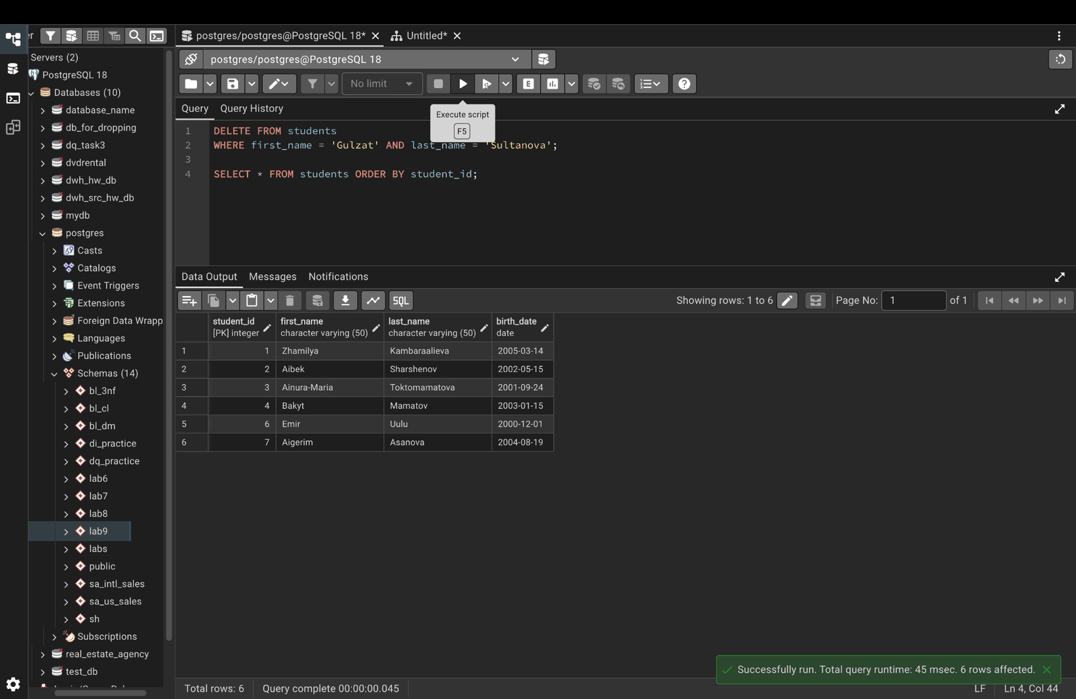

Step 8. Delete by condition
Removes everyone born before 2001.
DELETE FROM students
WHERE birth_date < '2001-01-01'
RETURNING *;
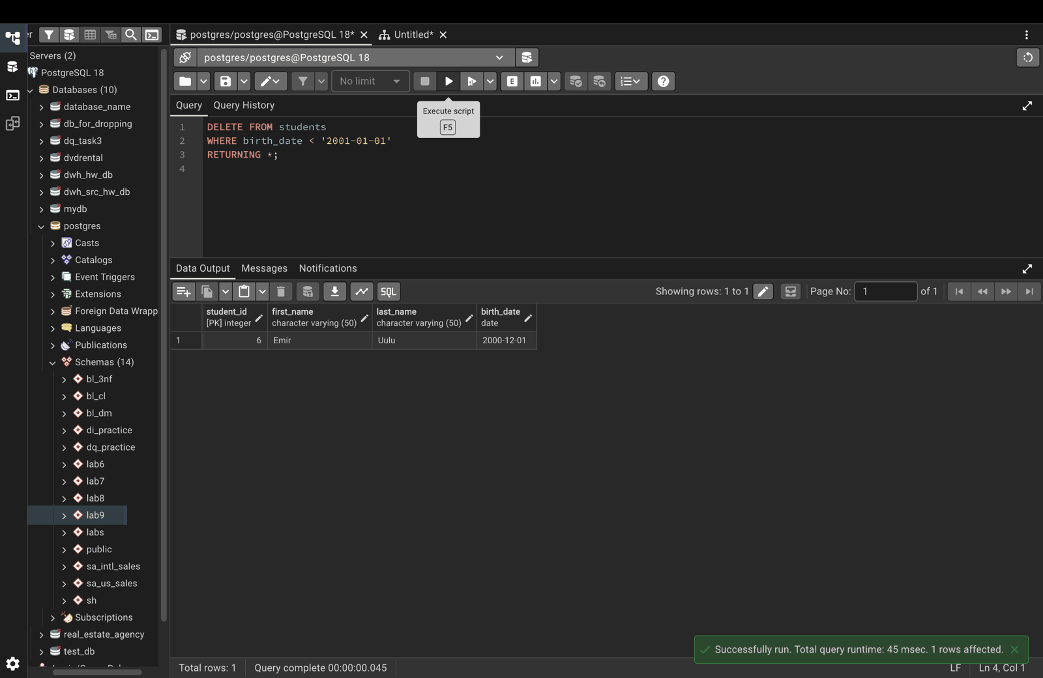

Step 9. Why WHERE matters (safe demo)
DELETE without WHERE removes every row. Here it runs inside a transaction and ROLLBACK undoes it, so no data is lost.
BEGIN;
DELETE FROM students;
SELECT COUNT(*) AS rows_left FROM students;
ROLLBACK;
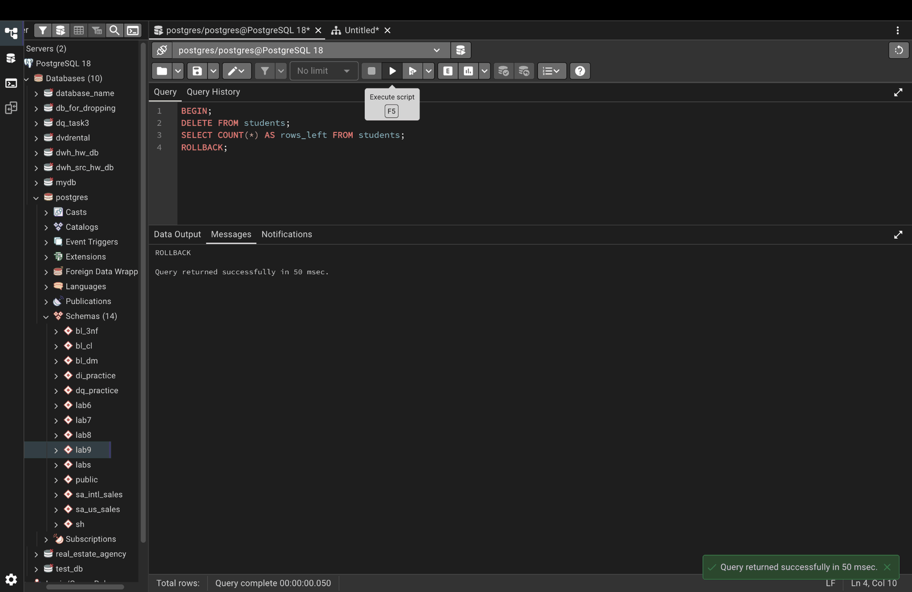

Step 10. Check the data is still there
SELECT * FROM students ORDER BY student_id;
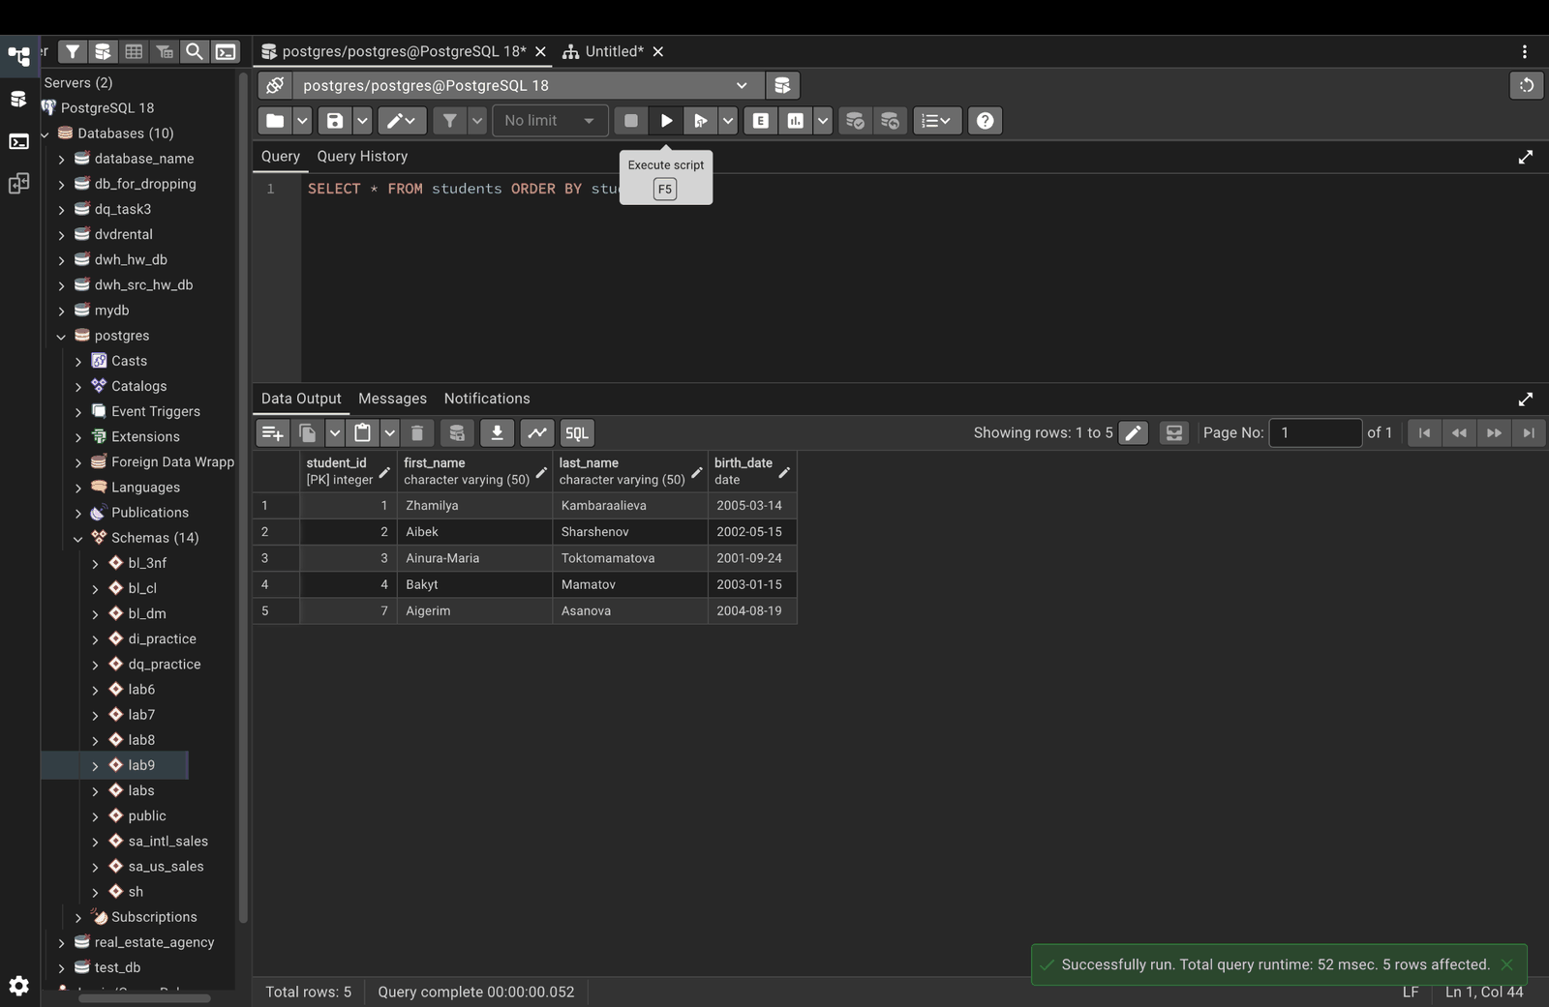

Part 4. Bulk operations

Step 11. Create a CSV file (Mac Terminal, not pgAdmin)
cat > /tmp/students.csv << 'EOF'
first_name,last_name,birth_date
Nursultan,Isakov,2002-04-10
Meerim,Bekova,2003-06-12
Tilek,Usubaliev,2001-11-05
Aruuke,Isakov,2003-02-20
EOF
cat /tmp/students.csv
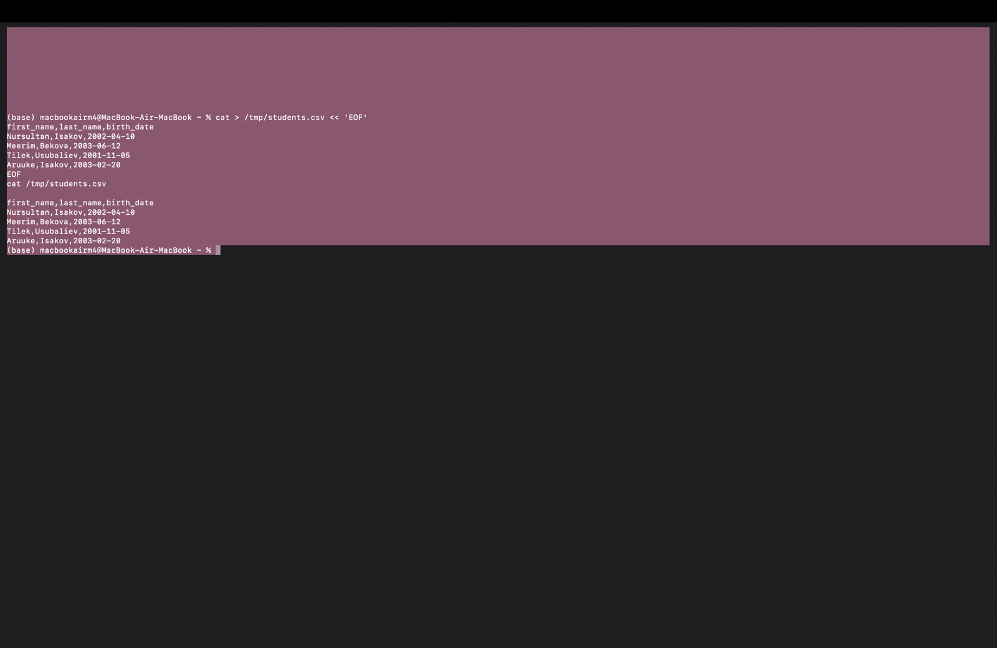

Step 12. Bulk insert with COPY (back in pgAdmin)
COPY students (first_name, last_name, birth_date)
FROM '/tmp/students.csv'
DELIMITER ','
CSV HEADER;
SELECT * FROM students ORDER BY student_id;
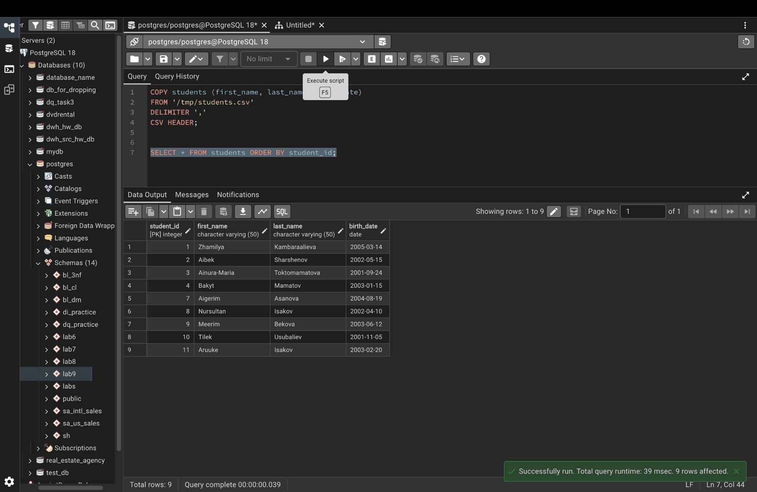

Step 13. Bulk update
UPDATE students
SET last_name = 'Bekov'
WHERE last_name IN ('Uulu', 'Isakov')
RETURNING *;
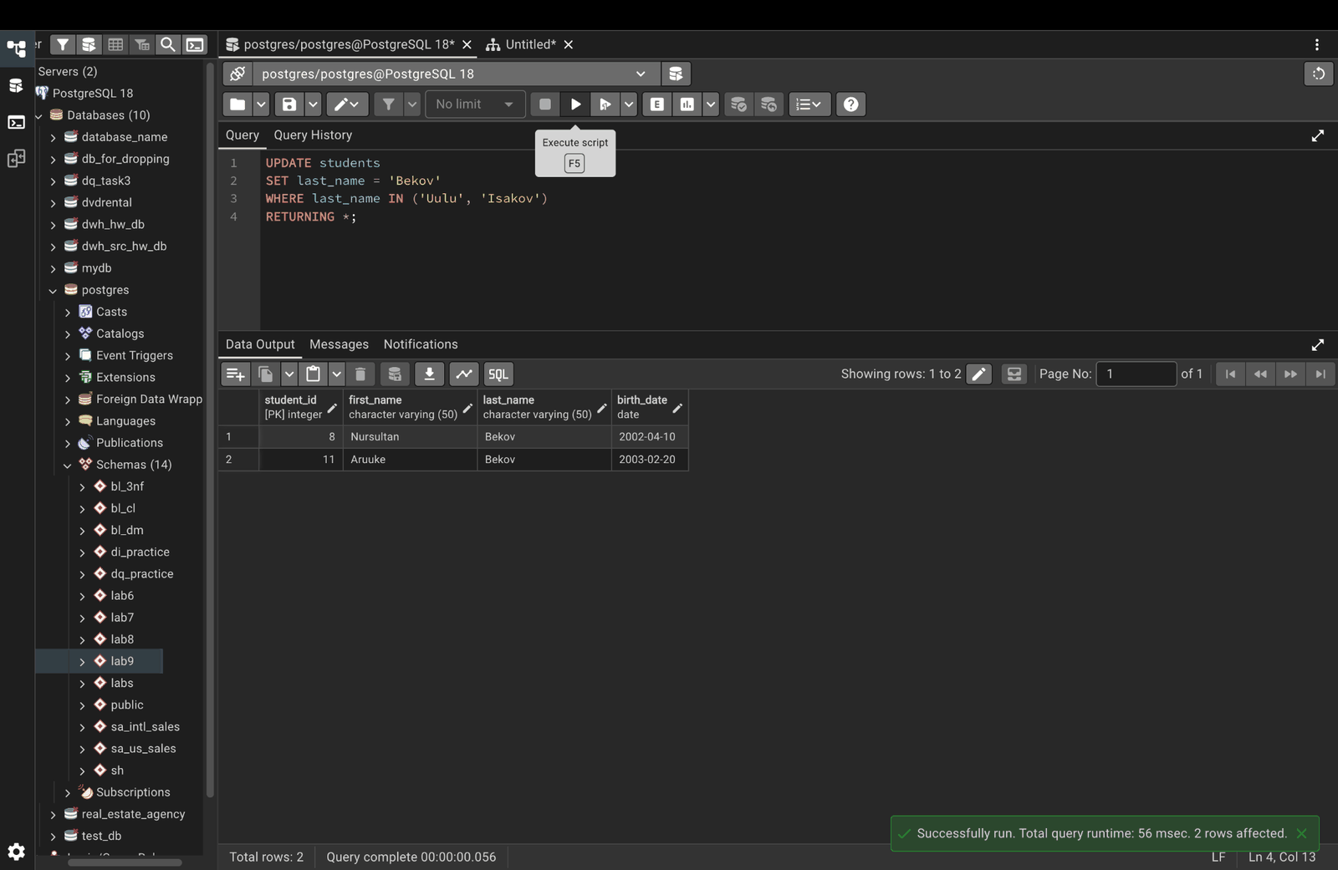

Step 14. Bulk delete
DELETE FROM students
WHERE student_id IN (2, 3, 5)
RETURNING *;
SELECT * FROM students ORDER BY student_id;
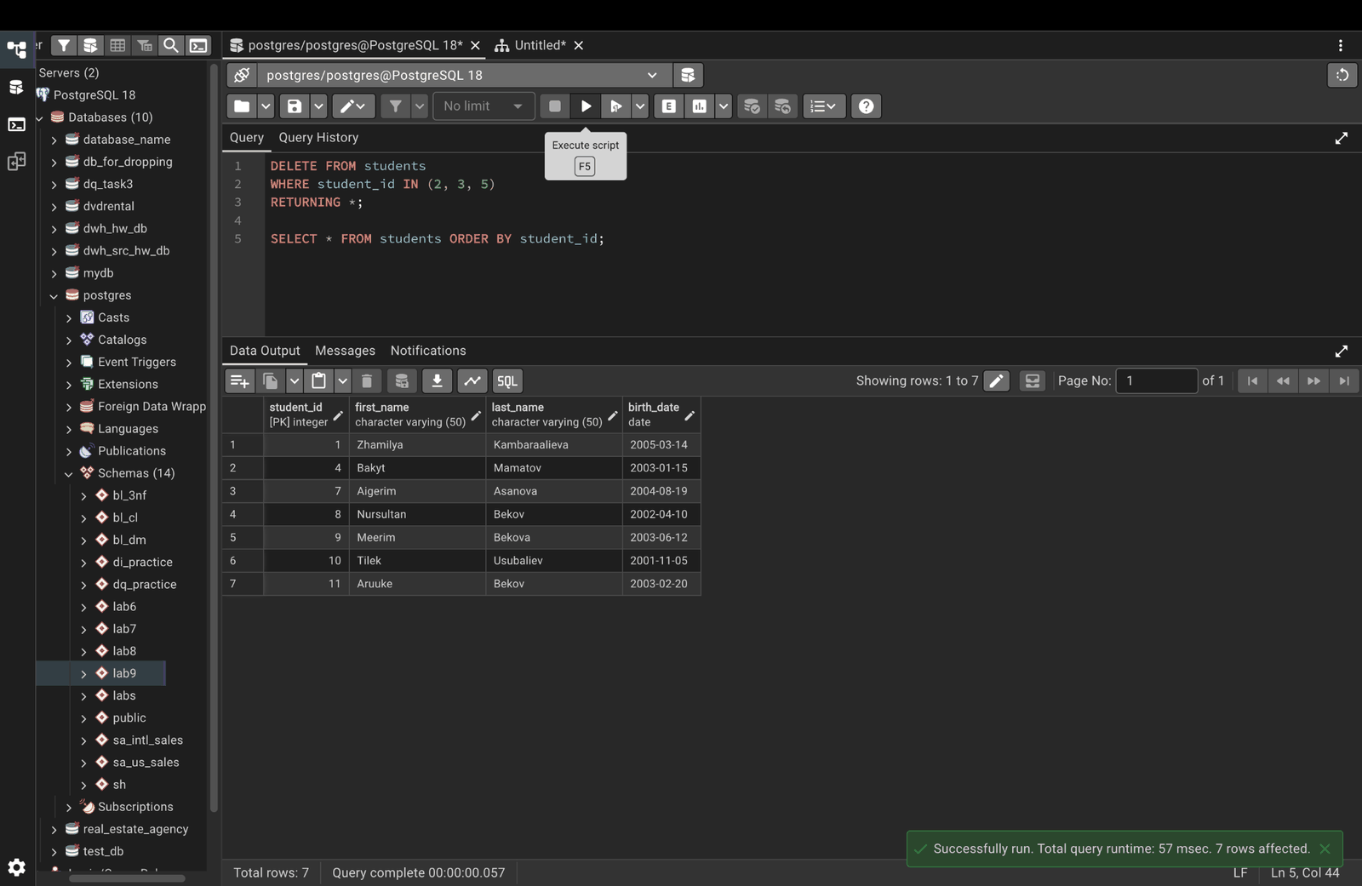

Step 15. Export the table to CSV with COPY
COPY (SELECT * FROM students ORDER BY student_id)
TO '/tmp/students_export.csv'
CSV HEADER;

Step 16. Check the exported file (Mac Terminal)
cat /tmp/students_export.csv
